How to Care Like Christ:
Changing Lives with Christ’s Changeless Truth



Robert W. Kellemen, Ph.D., LCPC
RPM Ministries
www.rpmministries.org, rpm.ministries@gmail.com

Christ-Centered, Comprehensive, Compassionate, and Culturally-Informed
Biblical Counseling and Spiritual Formation

© 2009

How to Care Like Christ:
Changing Lives with Christ’s Changeless Truth

Introduction: What to Do After the Hug—Scripture and Soul

- What About Bob?

- What to Do After the Hug: Navigating the Maze

- Lost Without a GPS

- We Need a Spiritual Friendship GPS: God’s Powerful Scriptures

- Scripture and Soul: 1 Thessalonians 2:8

- The Soul Physician and the Spiritual Friend

Sharing the Story of Our Spiritual Friendship Journey—Pastor Carl’s Story

- “Pastor Carl’s Story” raises vital questions to ponder:

1. Where would you start with Pastor Carl and why?

2. How would you minister to Pastor Carl in his suffering?

3. How would you minister to Pastor Carl in his struggle against sin?

4. What “map,” or “process,” or “plan,” or “model” would guide you as you helped Pastor Carl with his suffering and his sinning?

Overview: Why We Are Here/My Promise to You

Everyone wants to “do biblical counseling” and to “be a spiritual friend,”
but what does it actually look like in practice?
We will learn how to use God’s Word to bring Christ’s hope to people’s suffering.
We’ll explore practically how to offer sustaining care for discouraged people by weeping with those who weep—learning how to empathize with people’s hurts.
We’ll discover how to offer healing comfort for suffering people by exploring Christ’s hope in the midst of our grief—learning how to encourage people by relating Christ’s truth to their daily lives.

Preview: Our Spiritual Friendship GPS

- See the Chart on the Next Page

Soul Care and Spiritual Direction
Sustaining, Healing, Reconciling, and Guiding

Soul Care: The Evils We Have Suffered

“God Is Good Even When Life Is Bad”

Soul care givers compassionately identify with people in pain
and redirect them to Christ and the Body of Christ
to sustain and heal their faith so they experience
communion with Christ and conformity to Christ
as they love God (exalt God by enjoying and trusting Him) and love others.

Sustaining: “It’s Normal to Hurt”

Sense Your Spiritual Friend’s Earthly Story of Despair

Empathize with and Embrace Your Spiritual Friend

Healing: “It’s Possible to Hope”

Stretch Your Spiritual Friend to God’s Eternal Story of Hope

Encourage Your Spiritual Friend to Embrace God

Spiritual Direction: The Sins We Have Committed

“God Is Gracious Even When I Am Sinful”

Spiritual directors understand spiritual dynamics
and discern root causes of spiritual conflicts,
providing loving wisdom that reconciles and guides people so they experience
communion with Christ and conformity to Christ
as they love God (exalt God by enjoying and trusting Him) and love others.

Reconciling: “It’s Horrible to Sin, but Wonderful to Be Forgiven”

Strip Your Spiritual Friend’s Enslaving Story of Death

Expose Your Spiritual Friend’s Sin and God’s Grace

Guiding: “It’s Supernatural to Mature”

Strengthen Your Spiritual Friend with Christ’s Empowering Story of Life

Equip and Empower Your Spiritual Friend to Love

Soul Care: Comfort for Suffering

- Comfort: Called Along Side to Help—Parakaletic (Holy Spirit Our Comforter/Counselor)

- Suffering and Sanctification: “God Is Good Even When Life Is Bad”

I. Sustaining—“It’s Normal to Hurt”

A. __________________ to Your Spiritual Friend’s Earthly Story: 2 Corinthians 1:3-8

- Do Not Be Ignorant of One Another’s Suffering: 2 Corinthians 1:3-8

B. ______________________ with Your Spiritual Friend’s Earthly Story: Romans 12:15

- Sustaining Pictured: Climb in the _________________!

- Compassionate Commiseration

C. __________________ Your Spiritual Friend in His/Her Earthly Story: Hebrews 4:15

- People Need Our ___________________ More Than Our Speeches

- Shared Sorrow Is ___________________ Sorrow

D. __________________ Your Spiritual Friend’s Earthly Story: Romans 9:2-3; John 1:14

- _______________________ Suffering

E. Point Your Spiritual Friend to ________________ in His/Her Earthly Story: 1 Peter 5:1-4

- Jesus with ____________ On

F. Engage in ___________________ Trialogues with Your Spiritual Friend: Matthew 18:20

So What? Growing As a Soul Care-Giver

1. Who has sustained you by helping you to sense that “it’s normal to hurt”? Who has “climbed in the casket” with you? How?

2. How might Jesus sustain Pastor Carl?

3. How could you use the principles of sustaining to empathize with and comfort Pastor Carl?

II. Healing—“It’s Possible to Hope”

A. Stretch Your Spiritual Friend to the _________________ Story: 2 Corinthians 1:9-11

- When Life Stinks, Our Perspective_______________

- ____________ Christ Back Into the Picture

- Ask: “What Is God Up To in This?”

- Healing Pictured: Celebrate the Empty _______________!

B. Stretch Your Spiritual Friend to ____________ Story: Ephesians 3:14-21

- Cling to Our Image of God’s ____________ __________

- Cling to Our Image of Who We Are in ______________

C. Stretch Your Spiritual Friend to the ________________ Story: Romans 8:17-39

- Travel Together on the Road to _______________ _______________

- Weave in the Truth: We Are More Than ________________________!

D. Stretch Your Spiritual Friend to the __________________ Story: 2 Kings 6:15-17

- See Life with _____________ Eyes

E. Stretch Your Spiritual Friend to the __________________ Story: Engage in Healing Trialogues

So What? Growing As a Soul Care-Giver

1. Who has joined you in the healing process by helping you to sense that “it’s possible to hope”? Who has “celebrated the resurrection with you” and stretched you to God? How?

2. How might Jesus heal Pastor Carl?

3. How could you use the principles of healing to encourage Pastor Carl to see and live life from God’s
perspective?

Conclusion: The Next Step—Resources for Caring Like Christ



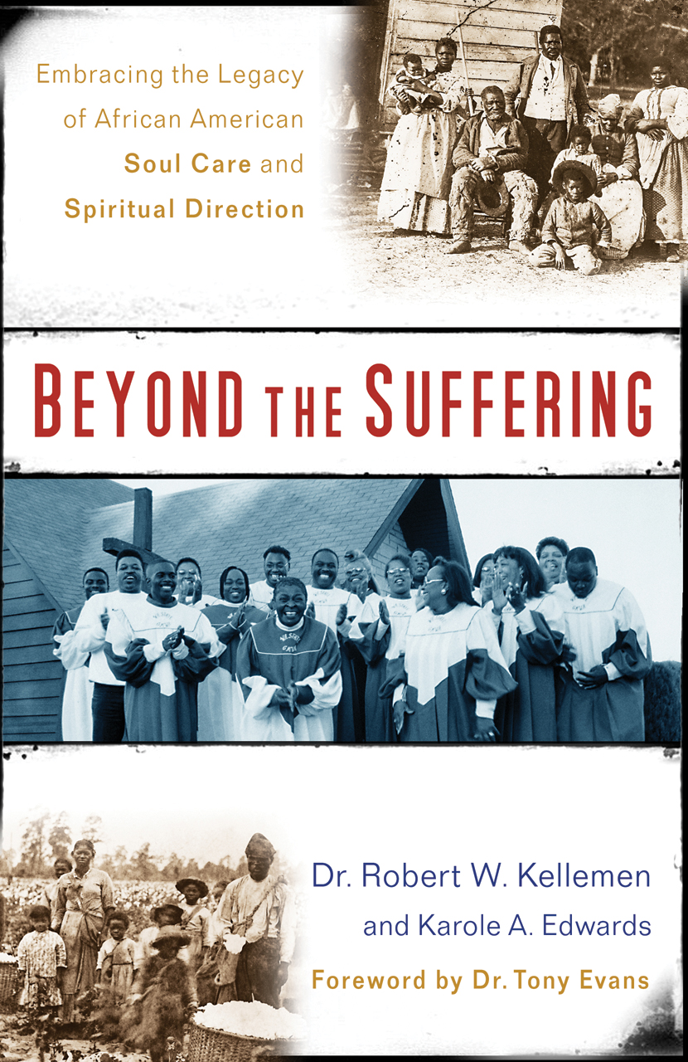


www.rpmministries.org
rpm.ministries@gmail.com

