A Sweet and Bitter Providence: Sex, Race, and the Sovereignty of God
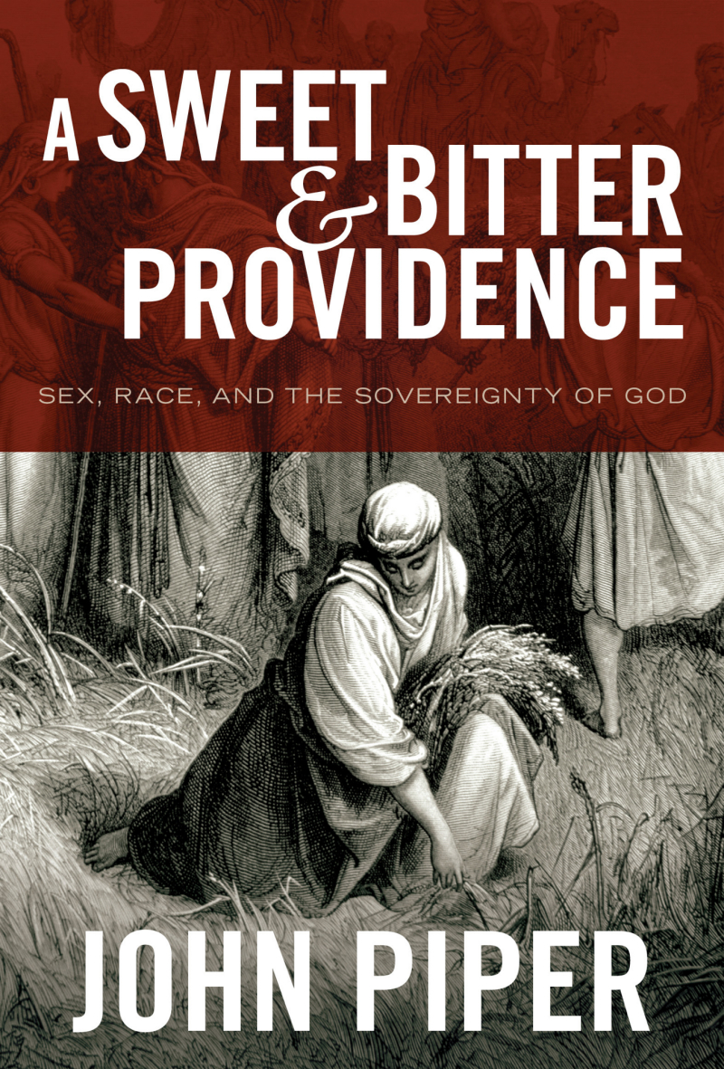
Reviewed By: Bob Kellemen, Ph.D., LCPC

Book Details

- Author: John Piper
- Publisher: Crossway Books (2010)
- Category: Christian Living, Theology

Recommended: John Piper’s A Sweet and Bitter Providence explores the book of Ruth to teach the powerful truth that God is at work even in the worst of times. In Piper’s able hands, we learn that God’s affectionate sovereignty brings glory to Christ, comfort to Christians, and hope that leads to risk-taking love for others.

God Is Good Even When Life Is Bad

Only a confident author like John Piper would begin his book saying he wasn’t “sure that you should read this book.” Of course, he then lists seven reasons why readers might be helped by the message of Ruth:

- Ruth is the Word of God which is our unwavering rock and anchor.
- Ruth is a love story—conveying the richest and deepest truths in the form of a passionate love story.
- Ruth is the portrait of beautiful, noble manhood and womanhood.
- Ruth addresses one of the great issues of our day: racial and ethnic diversity.
- Ruth’s most prominent purpose is to “bring the calamities and sorrows of life under the sway of God’s providence and show us that God’s purposes are good.”
- Ruth teaches risk-taking love—the gift of hope in God’s providence is meant to overflow in radical acts of love for hurting people.
- Ruth aims to show the glory of Christ—all of history, even its darkest hours, serves to magnify the glory of God’s grace.

God Is at Work in the Worst of Times

Piper gleans his title from Ruth 1:20-21, where Naomi, Ruth’s mother-in-law, candidly laments, “The Almighty has dealt very bitterly with me. I went away full, and the LORD has brought me back empty. The Almighty has brought calamity upon me.”

Summarizing his summary, Piper notes, “Here’s the question the book answers: Is God’s bitter providence the last word? Everywhere I look in the world today, whether near or far, the issue for real people in real life is, Can I trust and love the God who has dealt me this painful hand in life? That is the question the book of Ruth intends to answer.”

Piper’s answer, Ruth’s answer, Naomi’s answer, and God’s answer is clear: God is at work in the worst of times. The worst of times are not wasted—globally, historically, or personally. Piper’s quote of William Cowper’s verse says it well:

Judge not the Lord by feeble sense,
But trust him for his grace;
Behind a frowning providence
He hides a smiling face.

Piper makes the additional, important point that the answer to this question is meant not merely to help us to think right thoughts about God, nor merely to give us hope in His good providence. “That hope-filled confidence is meant to release radical, risk-taking love. It’s there to make you a new kind of person—a person who is able to ‘do justice, and to love kindness, and to walk humbly with your God’ (Micah 6:8).”

A Journey with Naomi, Ruth, and Boaz

The book is a brief, but rich, four-chapter journey through the four chapters of the book of Ruth. The trek begins with the trials and travails—the bitterness and calamity—of Naomi, her sons, and her daughters-in-law. Piper rightly affirms Naomi for her acceptance of the sovereignty of God even in the darkest days of her life. “When the world is crashing in, we need assurance that God reigns over it all.”

Piper somewhat takes Naomi to task, perhaps more than I would, for not seeing with spiritual eyes God’s good purposes. I’m not sure that Naomi failed to see the goodness of God, so much as she was candidly lamenting the badness of life—a common theme in Job, Jeremiah, Lamentation, and the Psalms of Lament.

However, Piper is certainly not without feeling for Naomi and other sufferers. In fact, Piper obliterates the false stereotype that a Gospel-centered, Reformed focus on God’s sovereignty is somehow cold, calculating, and emotionless. Rather, A Sweet and Bitter Providence is an emotion-provoking, passionate, and compassionate read. Piper’s writing wraps the words of the Bible around the heart of the sufferer.

Piper is at his best in chapter two as he explores how God turns Naomi’s mourning into dancing. He describes the key to facing suffering face-to-face with God: take refuge under God’s wing (Ruth 2:12). As Piper puts it, “Seek refuge under the wings of God, even when they seem to cast only shadows, and at just the right time God will let you look out from his Eagle’s nest onto some spectacular sunrise.” By esteeming God’s protection to be superior to all others, love-releasing hope develops. Humble confidence in the mighty and merciful wings of God leads to risk-taking love.

Chapter three is intriguing, with some interesting analysis of the plans of Naomi, Ruth, and Boaz, that some preachers, commentators, and theologians might disagree with at points. However, Piper’s overall theme is clearly biblical. He calls it “strategic righteousness.” Hope helps us dream. Hope helps us think up ways to do good. Hope helps us pursue our ventures with virtue and integrity. Hopeful people not only survive, they thrive. They not only don’t retreat, they advance; they strive. They strive for strategic righteousness as Naomi, Ruth, and Boaz did in pursuing the eventual marriage relationship between Ruth and Boaz.

It is in this chapter that the subtitled word “sex” enters the picture. Piper has strong, challenging, biblical words to share about sexual purity today in light of the choices Ruth and Boaz made in a situation fraught with sexual temptation.

In chapter four, Piper addresses the reality that life is not a straight line leading to glory. It’s a mountain road with switchback after switchback—winding and troubled roads. And God is in all these strange turns. He’s plotting the course and managing the troubles with far-reaching purposes for our good and Christ’s glory. We see this in Ruth, of course, when we realize that she, a Moabite woman, becomes one of the ancestors of Christ.

Piper explains that understanding this eternal perspective is crucial to address one of the great diseases of our day—trifling, or spending our life on the trivial. We were meant to live for magnificent causes. “The book of Ruth wants to teach us that God’s purpose for his people is to connect us to something far greater than ourselves. God wants us to know that when we follow him, our lives always mean more than we think they do.”

This is where the subtitled word “race” becomes visible. Whereas with chapter three and sexual purity, Piper spent a good deal of time highlighting modern-day applications, the same cannot be said for race relations. This was the one disappointing aspect of the book, especially given its inclusion in the subtitle. It was there, but more implicit than explicit, more “back then” than “here and now.”

Seven Final Appeals

Piper ends with seven appeals based upon his seven reasons to read the book.

- Study the Scriptures: May the Lord awaken in you an insatiable hunger for his Word.
- Pursue Sexual Purity: Choose seeing God and desiring God over sexual license and a mere collection of appetites.
- Pursue Mature Manhood and Womanhood: Affirm and pursue the differences.
- Embrace Ethnic Diversity: Explode the forces of ethnocentrism and racism.
- Trust the sovereignty of God: God is good even when life is bad.
- Take the Risks of Love: The sovereign goodness of God is revealed to us not only for our comfort, but also to free us from the fear and selfishness that quashes the radical risks of love.
- Live and Sing to the Glory of Christ: It’s all about Him!

A Sweet and Bitter Providence is a splendid exposition and application of the story of Ruth to our lives today. The story of Naomi, Ruth, and Boaz plays out under the invisible hand of God, as told by the skillful hand of John Piper.

Link to Blog Post: http://bit.ly/ckXmsD

